GEAR POST  Waynesboro  Rotary Club  5780  July/Aug 2023 | President: Vonda Lacey  Secretary: Sarah Paiste  Treasurer: Jodi Tibbs  President Elect: Lora Hamp  Directors: Meg Huebeck, Erica Sayers, Tracey  Straight and Jim White  Gear Post: Francine Johnston & Michelle White
Welcome to a New Rotary Year!

June 29th  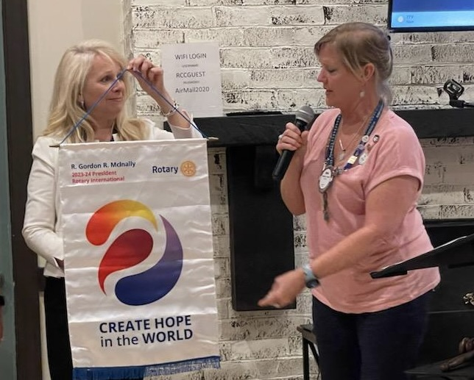  President-Elect Lora Hamp and President Vonda Lacey display the new Rotary International banner for 2023-2024 | Changing of the Guard and Awards  DG Nominee Andy Vanhook, Past President from the Harrisonburg Rotary Club, got the meeting started today. President Rebecca Shin thanked the Board of Directors for their work during the last year and presented a Certificate of Appreciation to Troy Hamilton for his service. All past presidents stood and passed the gavel starting with Bill Watkins (1989-1990) and ending with our new president. Sarah Paiste received her first Paul Harris Award, Polio Plus certificates were awarded to Meg Huebeck and Vonda Lacey for a $100 yearly commitment and a Service Above Self Award was presented to Erica Sayers. Congratulations to all!
July 13th  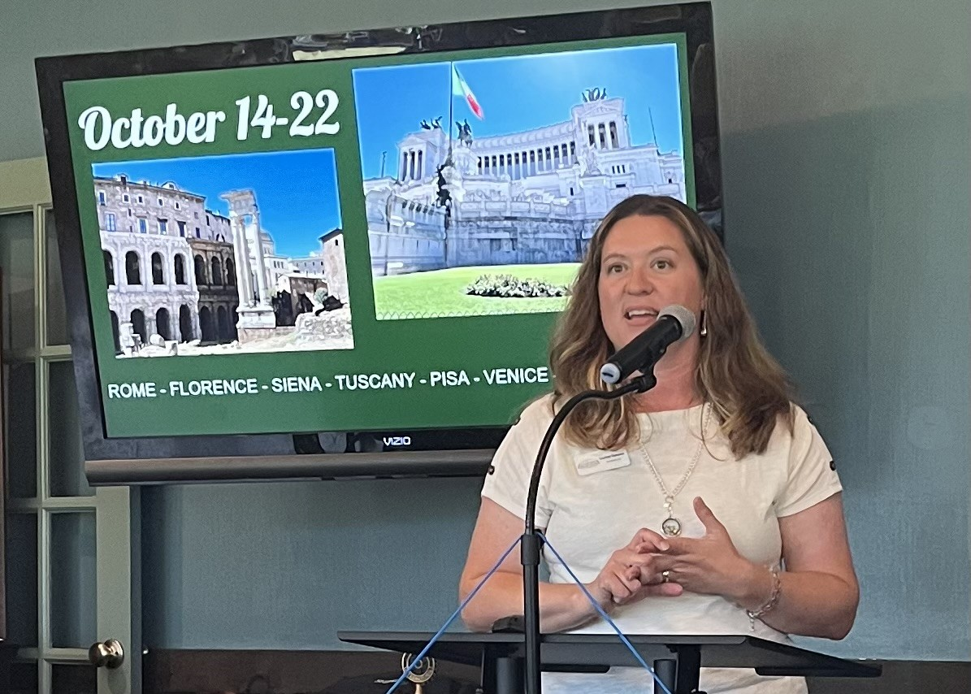 | Chamber of Commerce  Safiya Jarvis introduced our speaker today from the Greater Augusta Regional Chamber of Commerce - President Courtney Thompson. We learned some history of the Chamber and their goals to support local business from small entrepreneurs to large industries. They do this in many ways including bringing people together to share expertise and resources. Courtney also told us about Chamber Travel which sponsors yearly trips to different parts of the world -this year it’s to Italy!
July 20th | A.L.I.C.E. Updates  Our own Kristi Williams who is the President and CEO of United Way of SAW brought us updates on the 50% of local households who fall into the category of Asset Limited Income Constrained Employed (ALICE). Working families struggle to pay for housing, childcare, medical care, transportation, food etc. and are often just one paycheck away from poverty. Kristi shared a video which highlighted the impact of poverty on children that was particularly moving.
July 27th  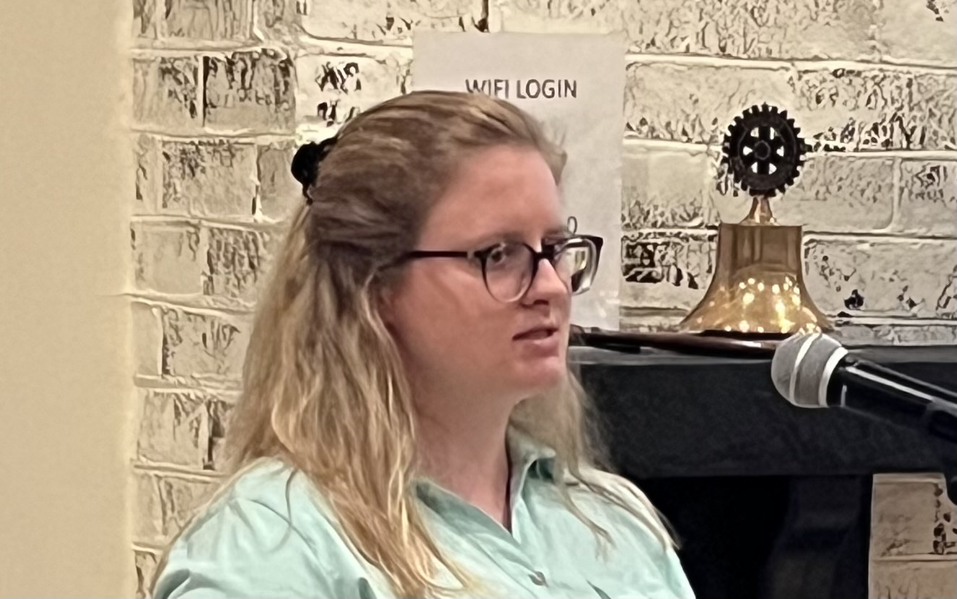 | Family Self Sufficiency Program  Lily Demastus from the Redevelopment and Housing Authority described a program she coordinates designed to help families become more financially independent and live without government assistance. She develops individualized plans and goals and then finds resources such as job training, childcare and money management. A savings account is established that can be used at the successful conclusion of the program for a down payment on a house or other long-term  investments. Lily is particularly interested in building a sense of community among people in public housing and seeks event sponsors.
August 3rd  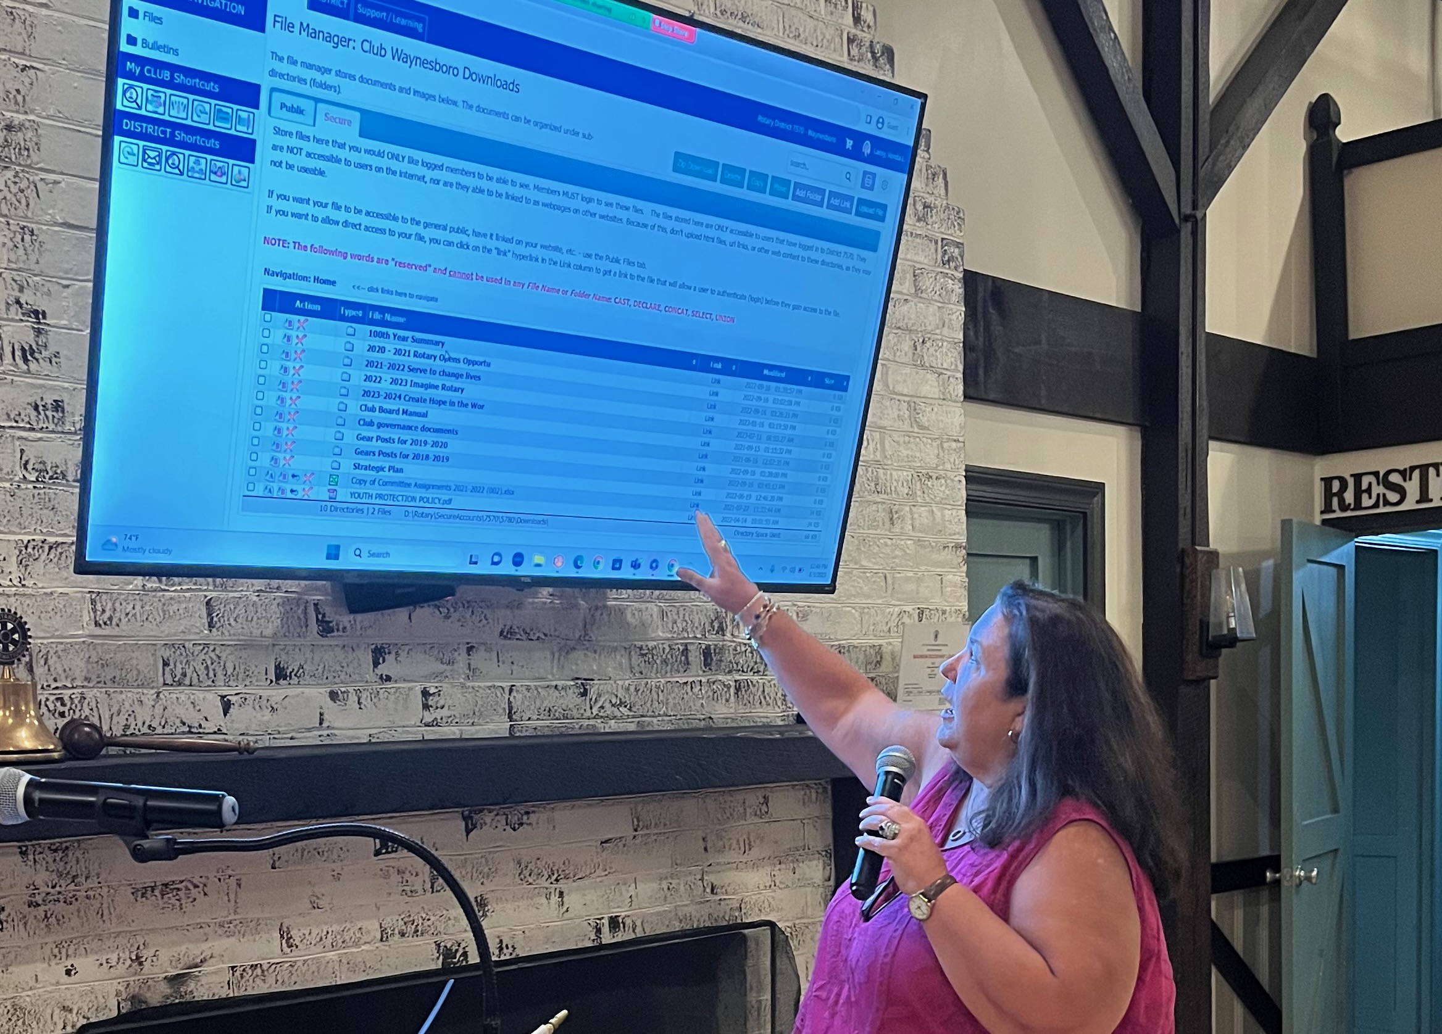 | What’s Up with Rotary  Today we heard from several officers. Jodi Tibbs is ready to write checks in her new position as treasurer. Sarah Paiste walked us through the DACdb website and encouraged everyone to update the data under their profile. Vonda showed us the website My Rotary which members should explore as well. It offers more information about you and the club. Sign in with your email and create your own password.
Our New President  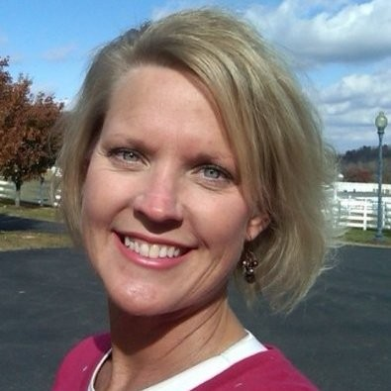 | Vonda Lacey grew up in Mableton Georgia where she displayed early leadership as president of her high school class for 3 out of 4 years. She first worked in food service, ending as owner and operator of Rosa’s Cantina in Staunton. She began her real estate career with Re/Max Advantage in 1996 where she is now an associate broker and sales associate. She has served on numerous real estate boards and committees. Vonda has three children and two grandchildren who all live nearby. She likes to read, garden, play with her dogs, and spend time with her family. Vonda joined our club in 2015, has served on the board of directors and is a Paul Harris Fellow.
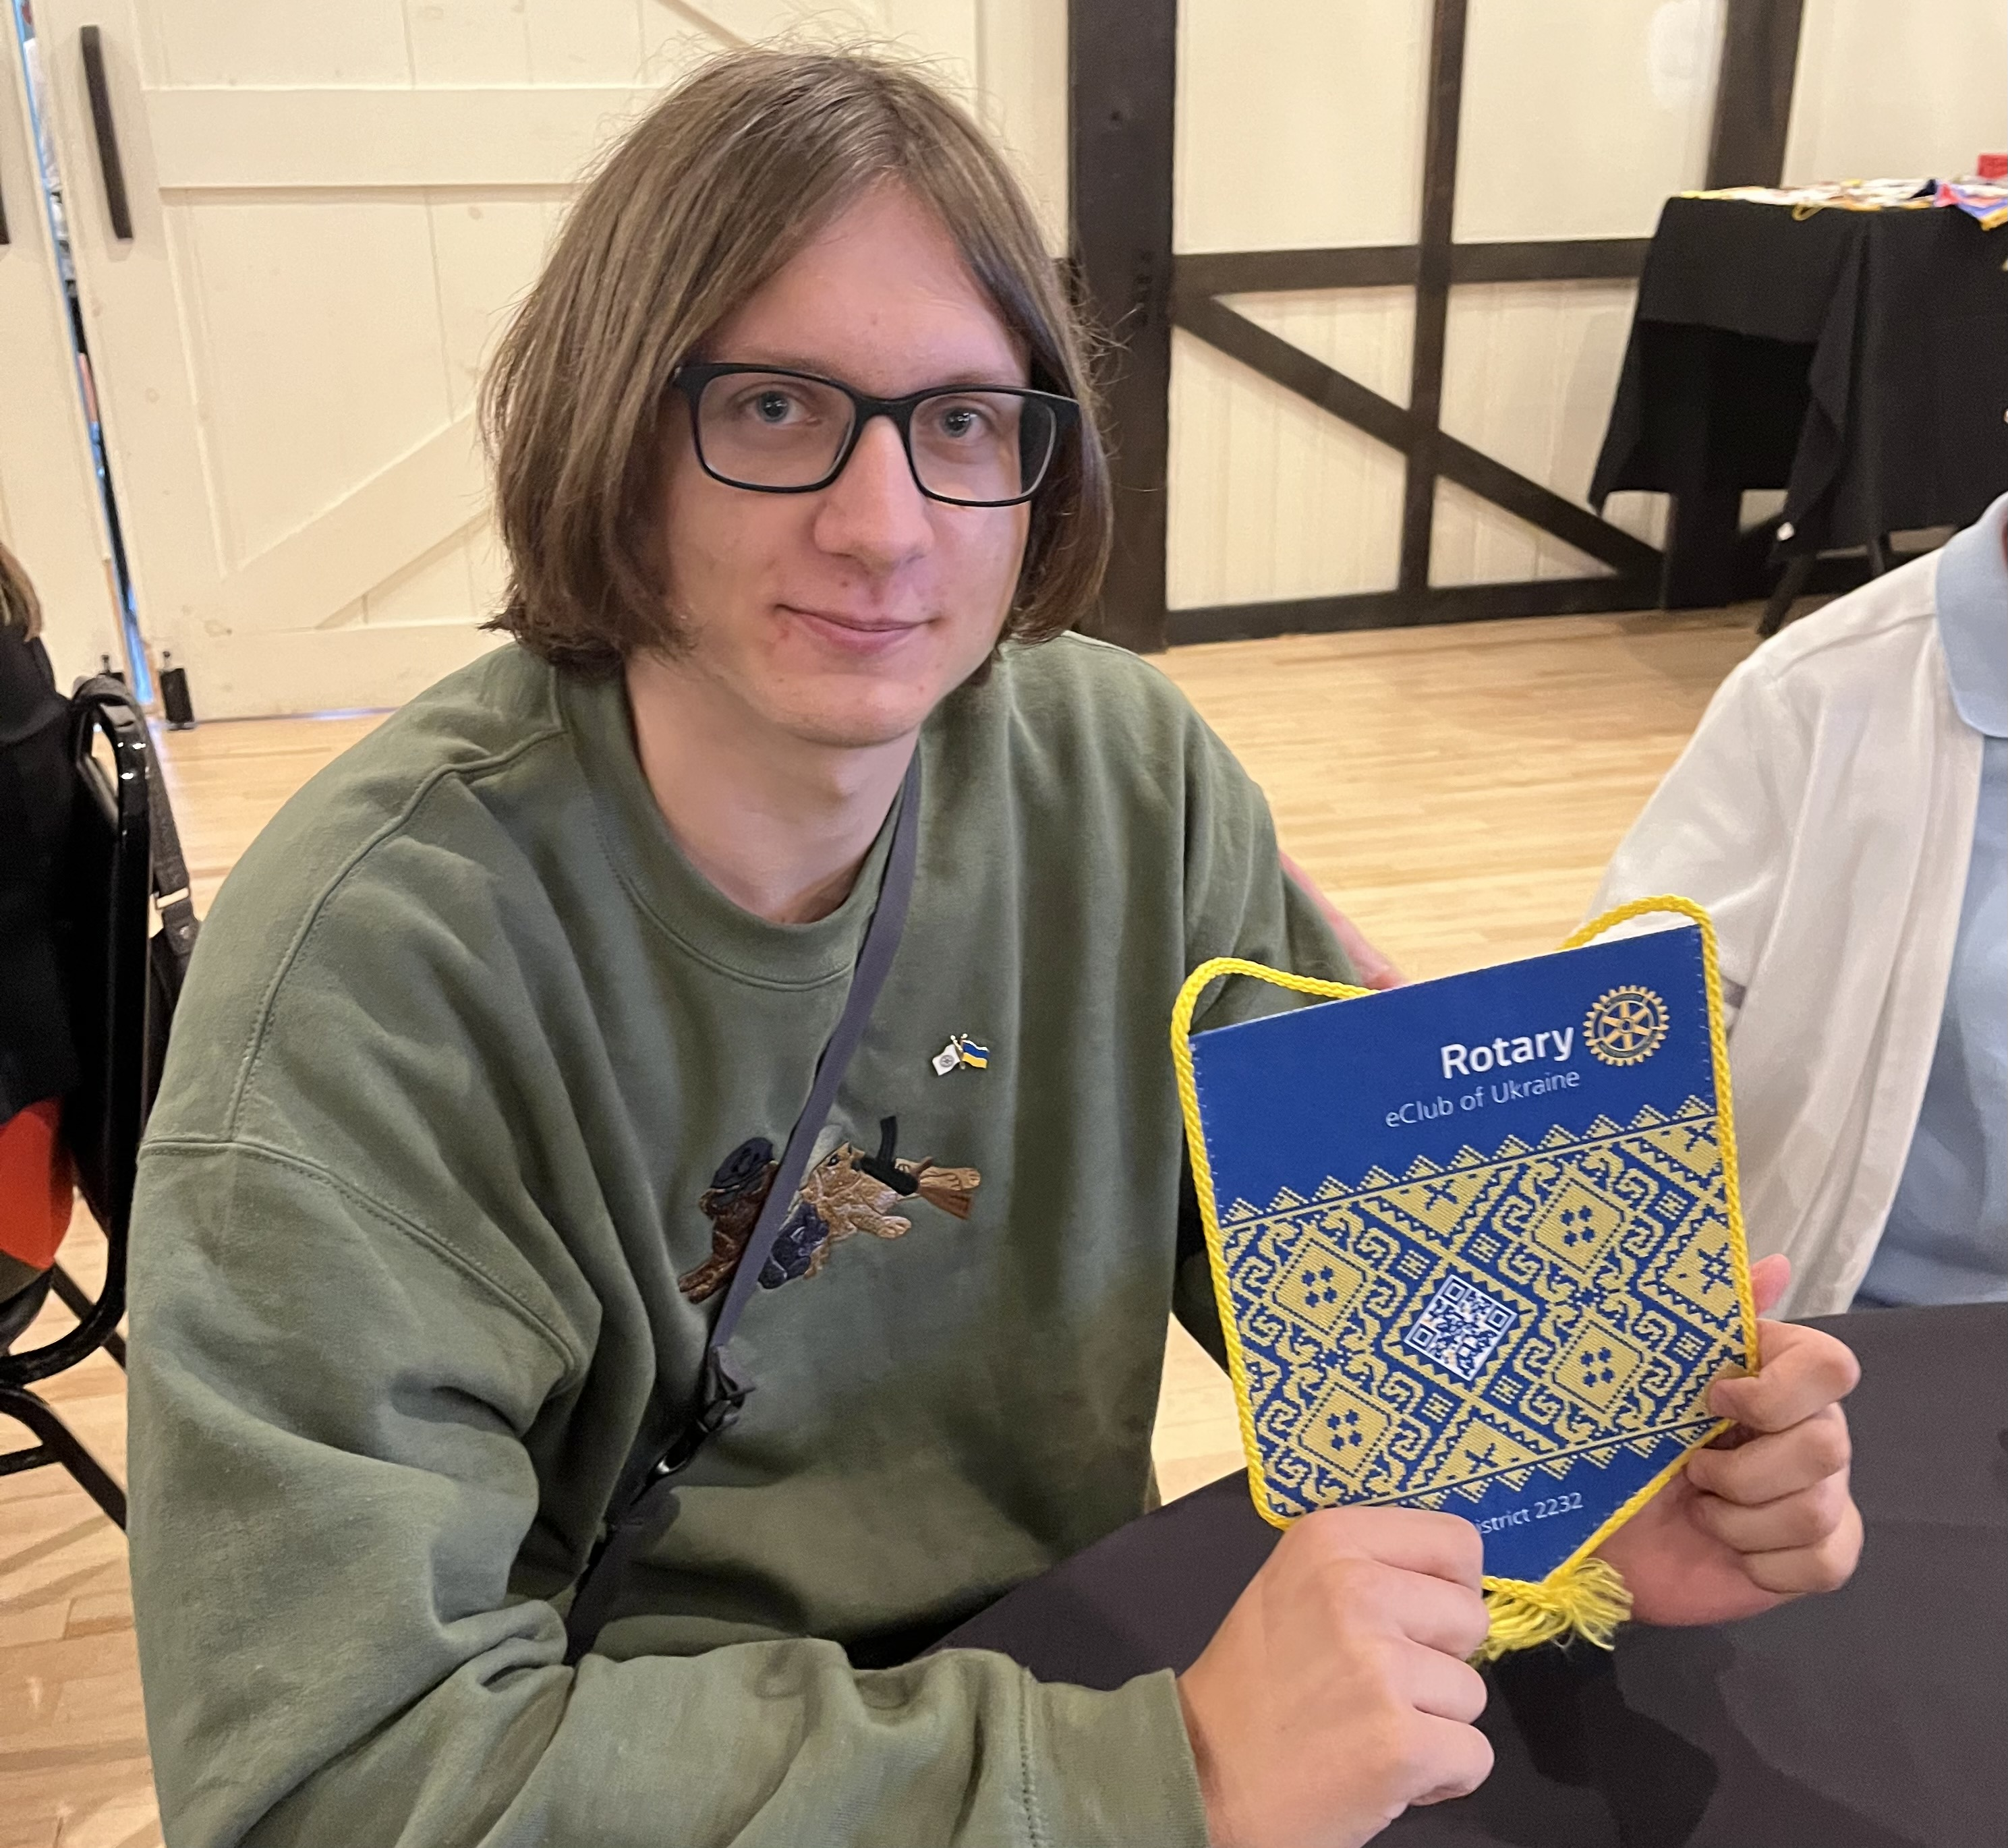  Demi displays a flag from the Rotary eClub of Ukraine | Welcome to our International Exchange Student: Demi Shevel  We met Demi on August 3rd - several days after he arrived at the home of the Paistes after 40 hours of travel. Demi is from the town of Mykolaiv Ukraine but has had to move to a safer town nearby due to bombing. He will be attending WHS as a 10th grader. He enjoys basketball and skateboarding and likes to work out. He regularly walks 20,000 steps a day! Demi also likes to read and draw. Do you have a skateboard to loan out? Demi couldn’t bring his and will miss it.
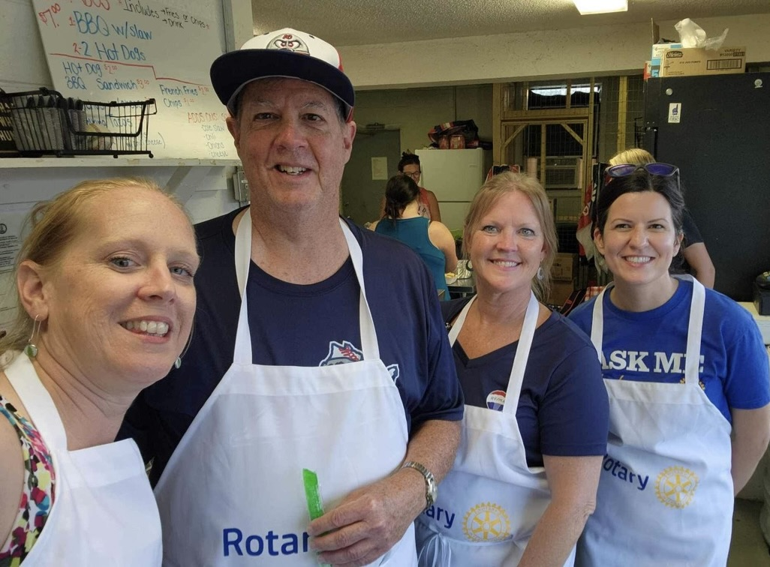  Jennifer Lewis, Mike Meadows, Vonda Lacey & Erica Sayers | Club Service  Four members worked at the concession stand during a recent Generals Game. Members also turned out to “Stuff the Bus” for United Way. Pictured are Kristi Williams, Jennifer Lewis, Mike Meadows and Michelle White. Other helpers included Jeff Cassell, Francine Johnston, Marcie Mader and Vonda Lacey. |  | 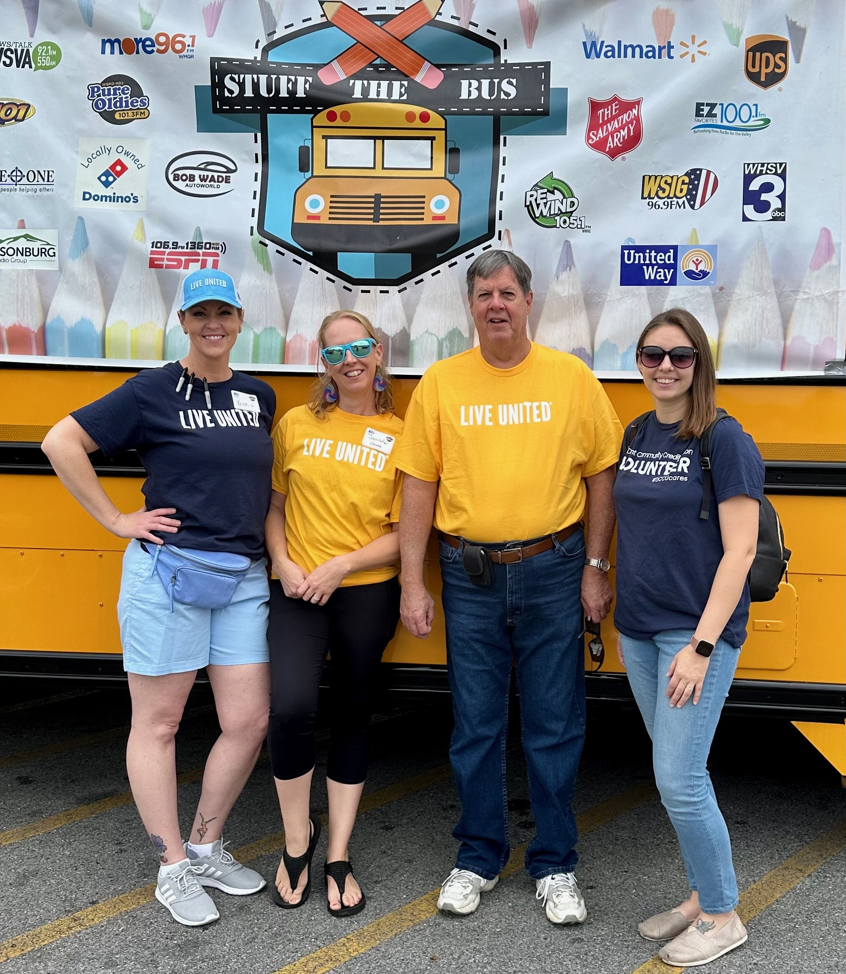
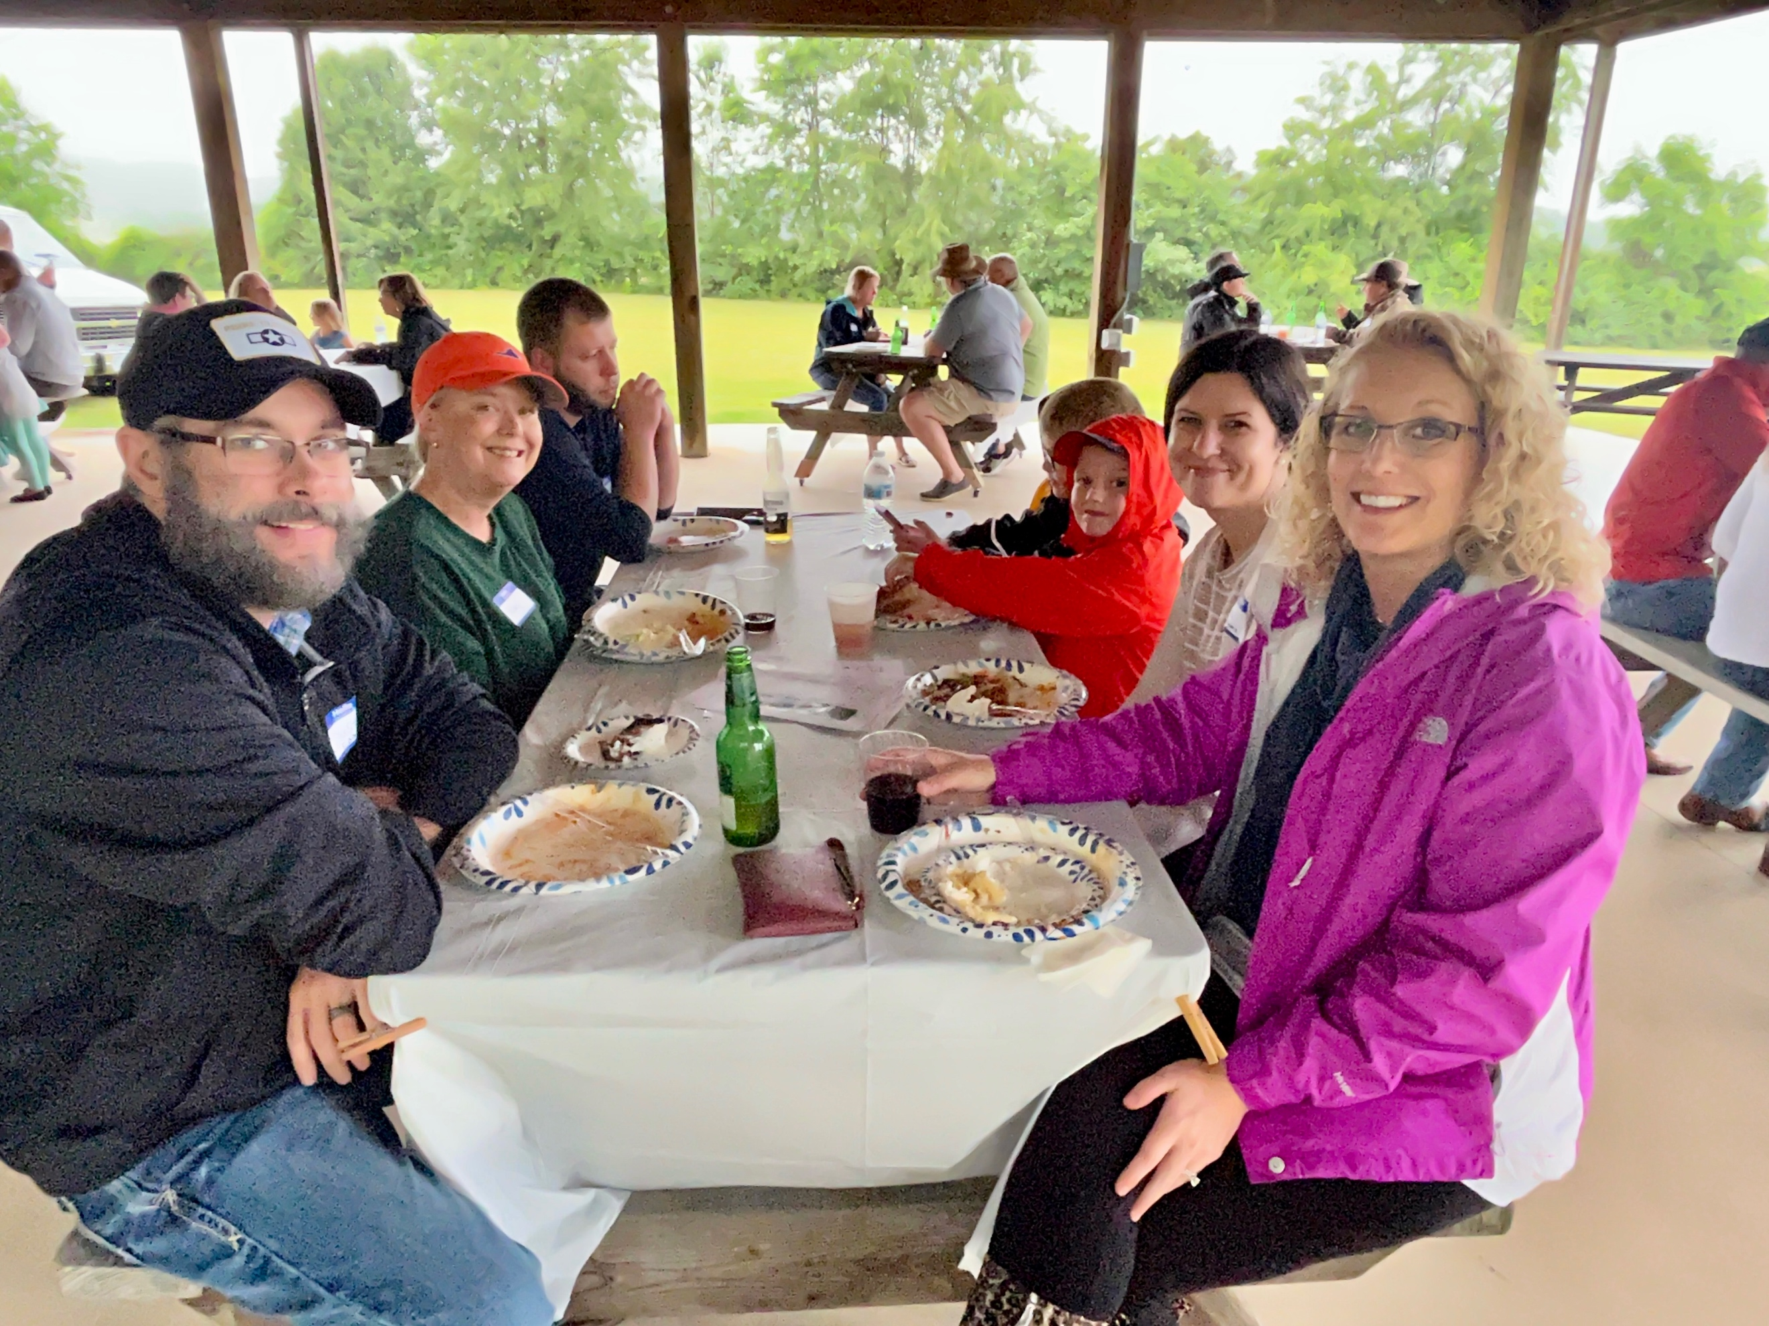 | Annual Family Picnic  Members, family and friends gathered at the Elks’ Club Pavilion on June 22nd to enjoy Rick’s barbecue. The cool and rainy weather did not dampen the spirits of folks who showed up in boots and rain jackets and some of the child-  ren got happily soaked running around. |  | 