GEAR POST  Waynesboro  Rotary Club  5780  October 2023 | President: Vonda Lacey  Secretary: Sarah Paiste Assistant: Kerri Garrison  Treasurer: Jodi Tibbs  President Elect: Lora Hamp  Directors: Meg Huebeck, Erica Sayers, Tracey  Straight and Jim White  Gear Post: Francine Johnston & Michelle White
Date to Remember | Family Christmas party at Fairfax Hall on December 7th at 5:30
September 21st  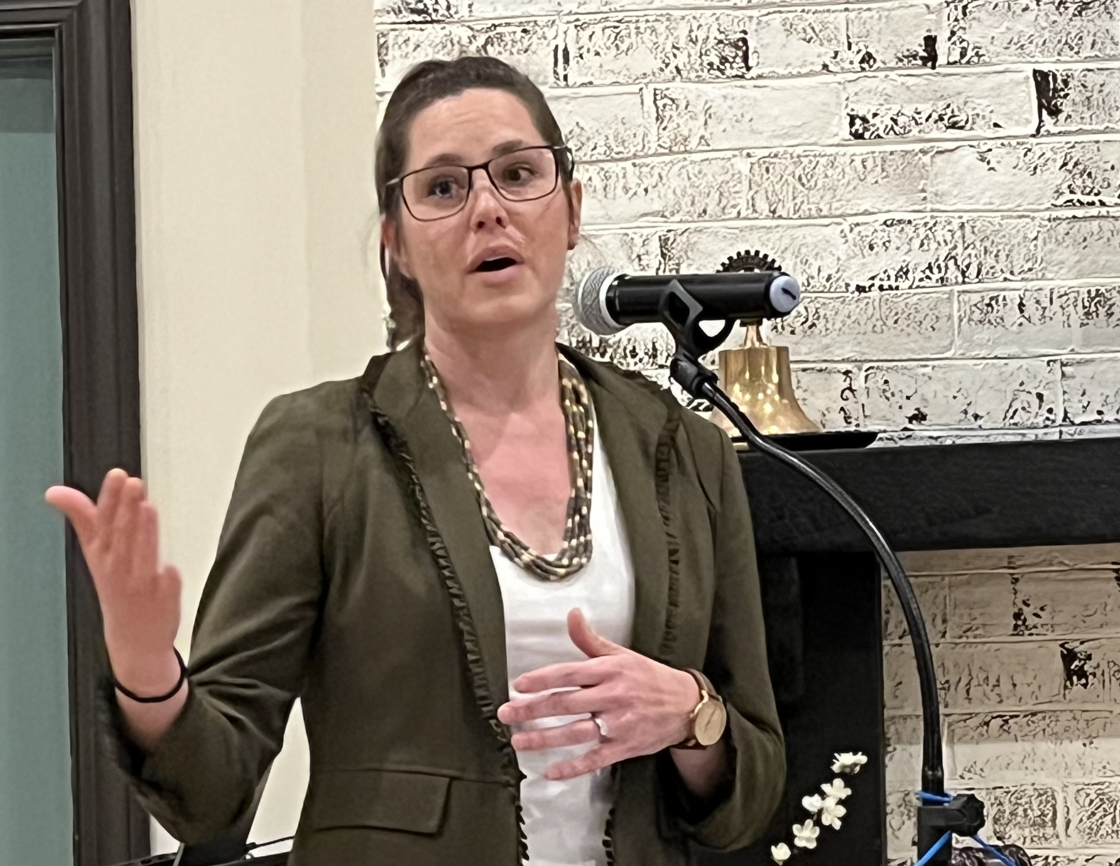 | Just Neighbors  Tori Babington is an attorney with Just Neighbors, an organization that serves VA and MD providing legal services for immigrants who seek citizenship. She spends one day a month in Waynesboro, having partnered with local agencies Embrace and Sin Barreras (who we heard from in July 2022). Tori shared her frustration with outdated and punitive immigration policies and reported that many of her clients are children under the age of 18 who have come to the US alone to seek family. If you know of anyone needing her help, contact Sin Barreras.
September 28th  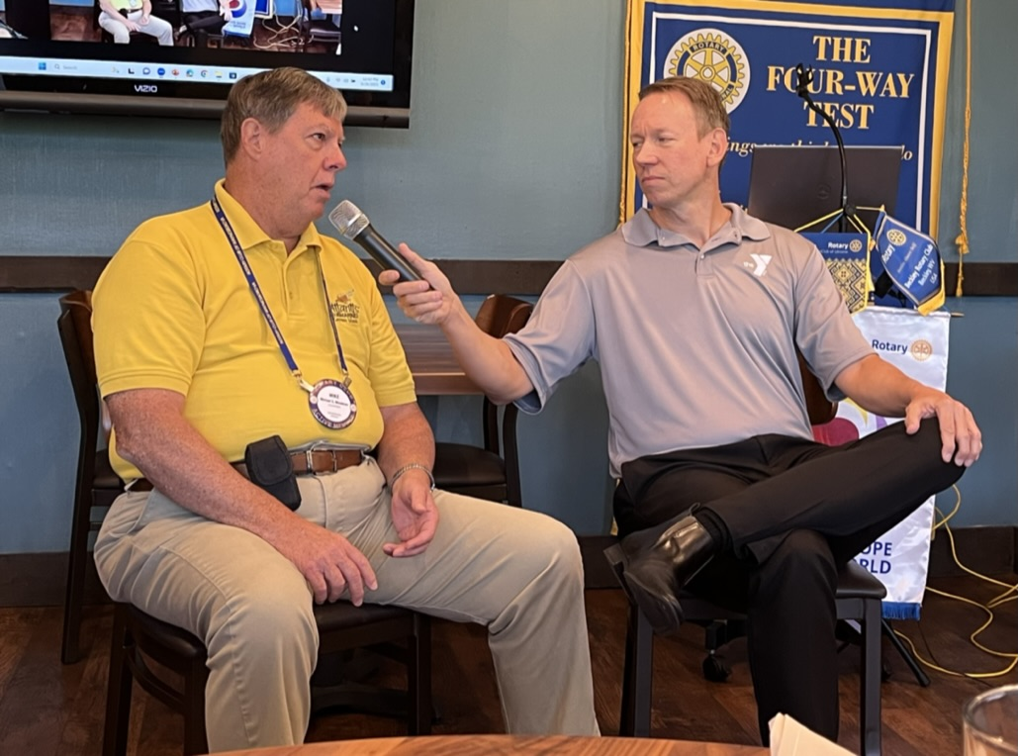 | Special Olympics  When our speaker cancelled, Jeff Fife came up with an alternative on the spot. He interviewed Mike Meadows about his 51 years of participating in Special Olympics. Mike has competed in a variety of events at local, state, and world games since he was 17. He recalled that swimming was probably his favorite sport, but he is now preparing to compete in a new event – pickleball. Although Mike has a lot of medals, he summed up his experiences with “Win or lose – have a good time”. Kudos to both guys for an interesting program.
October 5th  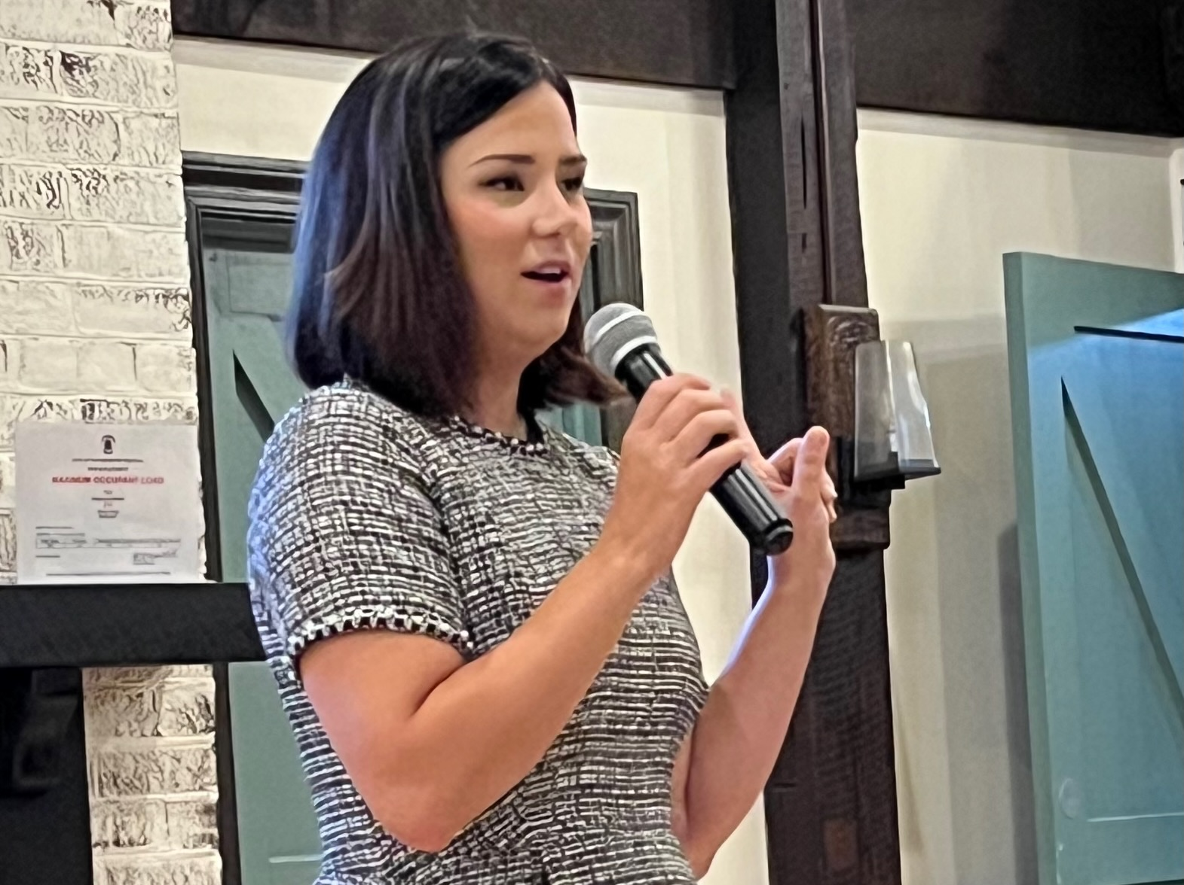 | The Innovation Hub and Co-working  Hannah Cooper, Regional Director of The Innovation Hub, joined us today to talk about the co-working services they offer. The Hub in downtown Staunton provides distraction free workspaces, conference rooms, fast internet, A-V technology and other resources. Workers can elect a membership to use communal spaces, a designated desk or a personal office. The Hub has contracts with 140 businesses and plans to open other co-working hubs in Harrisonburg and Waynesboro.
October 12th  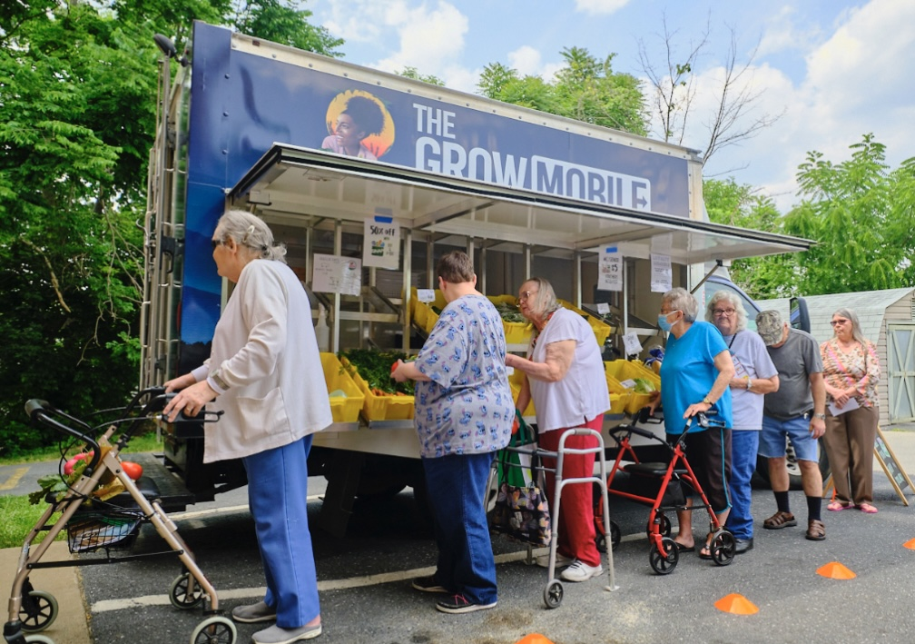 | Project Grows  How do you get kids to make healthy food choices and provide food to the neediest people in the community? Clare Metzler, Executive Director of Project Grows, told us about how they have addressed these problems through educational initiatives and marketing of the food they grow with the help of kids. The Grow Mobile (shown at left) takes food to folks in senior centers and the Boys & Girls Club. Shop for their produce at the Farmers Market, volunteer or donate!
October 19th  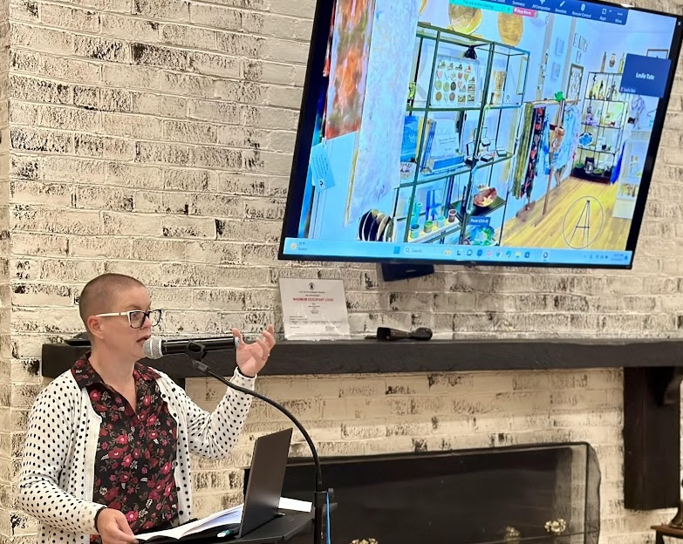 | Shenandoah Valley Art Center  Shenandoah Art Center, started in 1986, is located downtown on Wayne Avenue and it has expanded recently to a building on Main Street where it was part of this fall’s successful Foliage Festival. Piper Grove, executive director, told us about an upcoming exhibit by Rose Guterbock entitled “Power and Pain” and invited us to the Winter Market featuring ceramics opening Nov 3rd. She reminded us that artwork makes great holiday presents and supports local artists.
October 26th  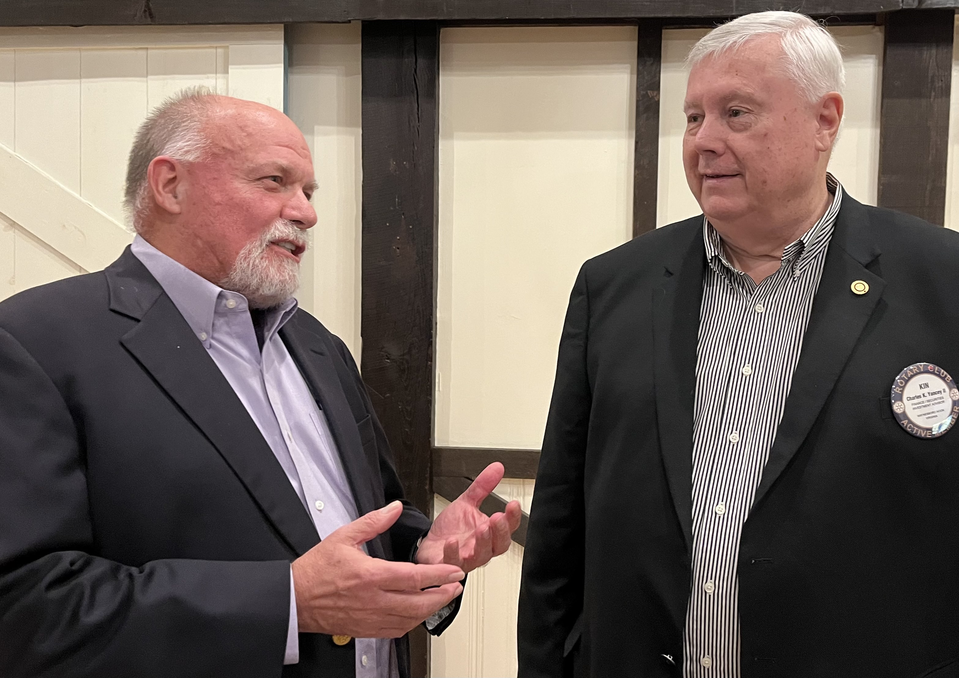  Our speaker chats with Kin Yancy | Ghost Tales  Walter Wilson is the new chairman of the board for The Waynesboro Heritage Museum. He shared tales of ghost sightings from the local area and around the state. Several houses in the tree streets may be haunted, cold drafts have been noted at Fairfax Hall and unexplained events reported at the Wilson Workforce Center. Walter has traveled to many sites around the country where paranormal events have been reported but he has only seen one ghost - his deceased father-in-law.
Notes from the Board | The Waynesboro East-Augusta Club has donated $500 to our club in support of our exchange student from Ukraine, Demi Shevel.
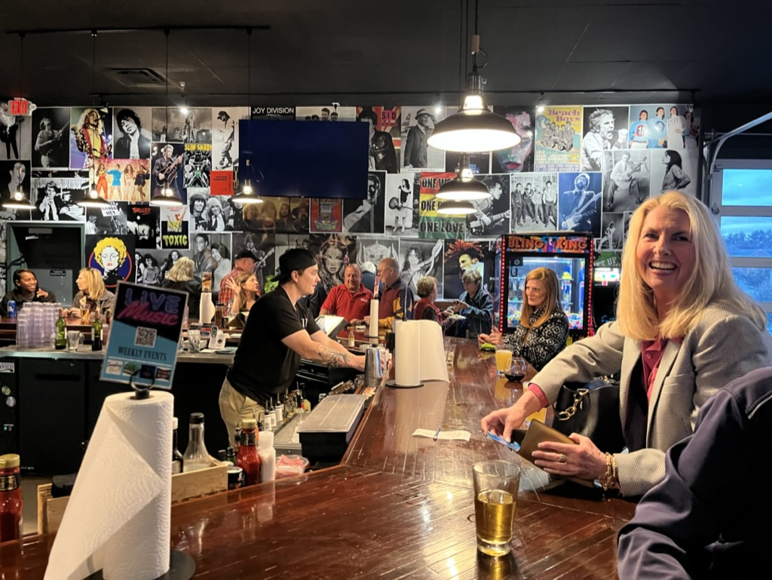  Margaret Hersh places her order | Area 4 Pints for Polio Plus  Six area clubs joined DG Paula Alston on Oct 17th at Third Generations Grill to raise a glass to fellowship and an end to polio. Members were encouraged to wear purple (for polio) and pink (for breast cancer awareness month). Our club donated $728 toward a record area total of $4,398! | 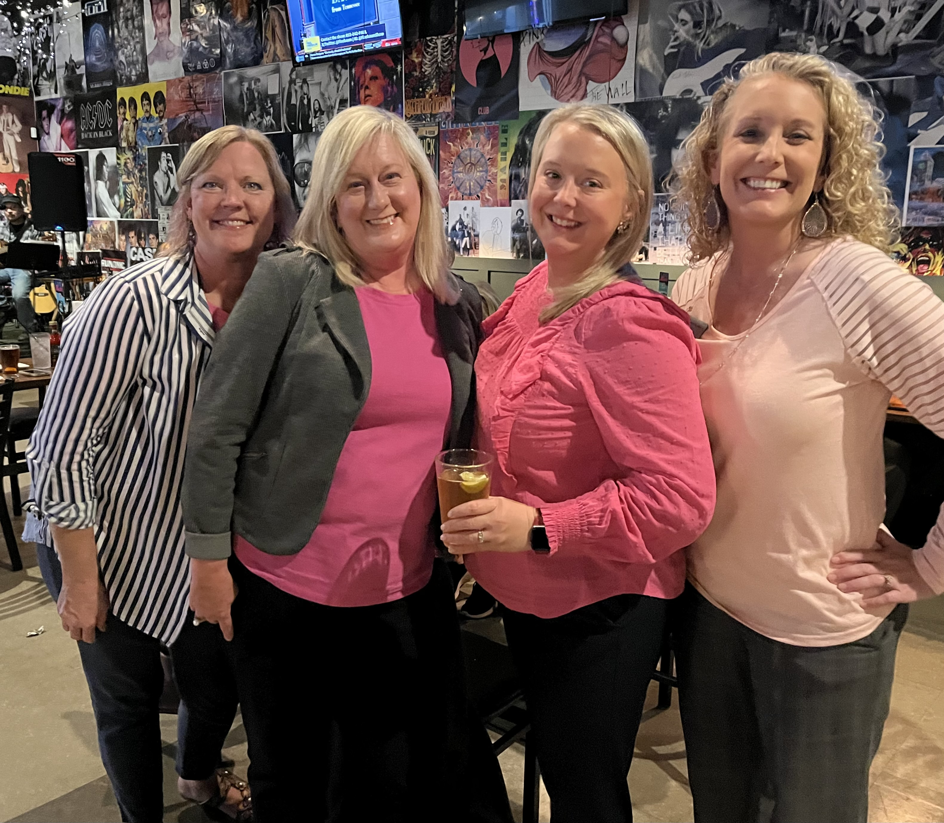  Vonda, Jodi, Hilary and Jan
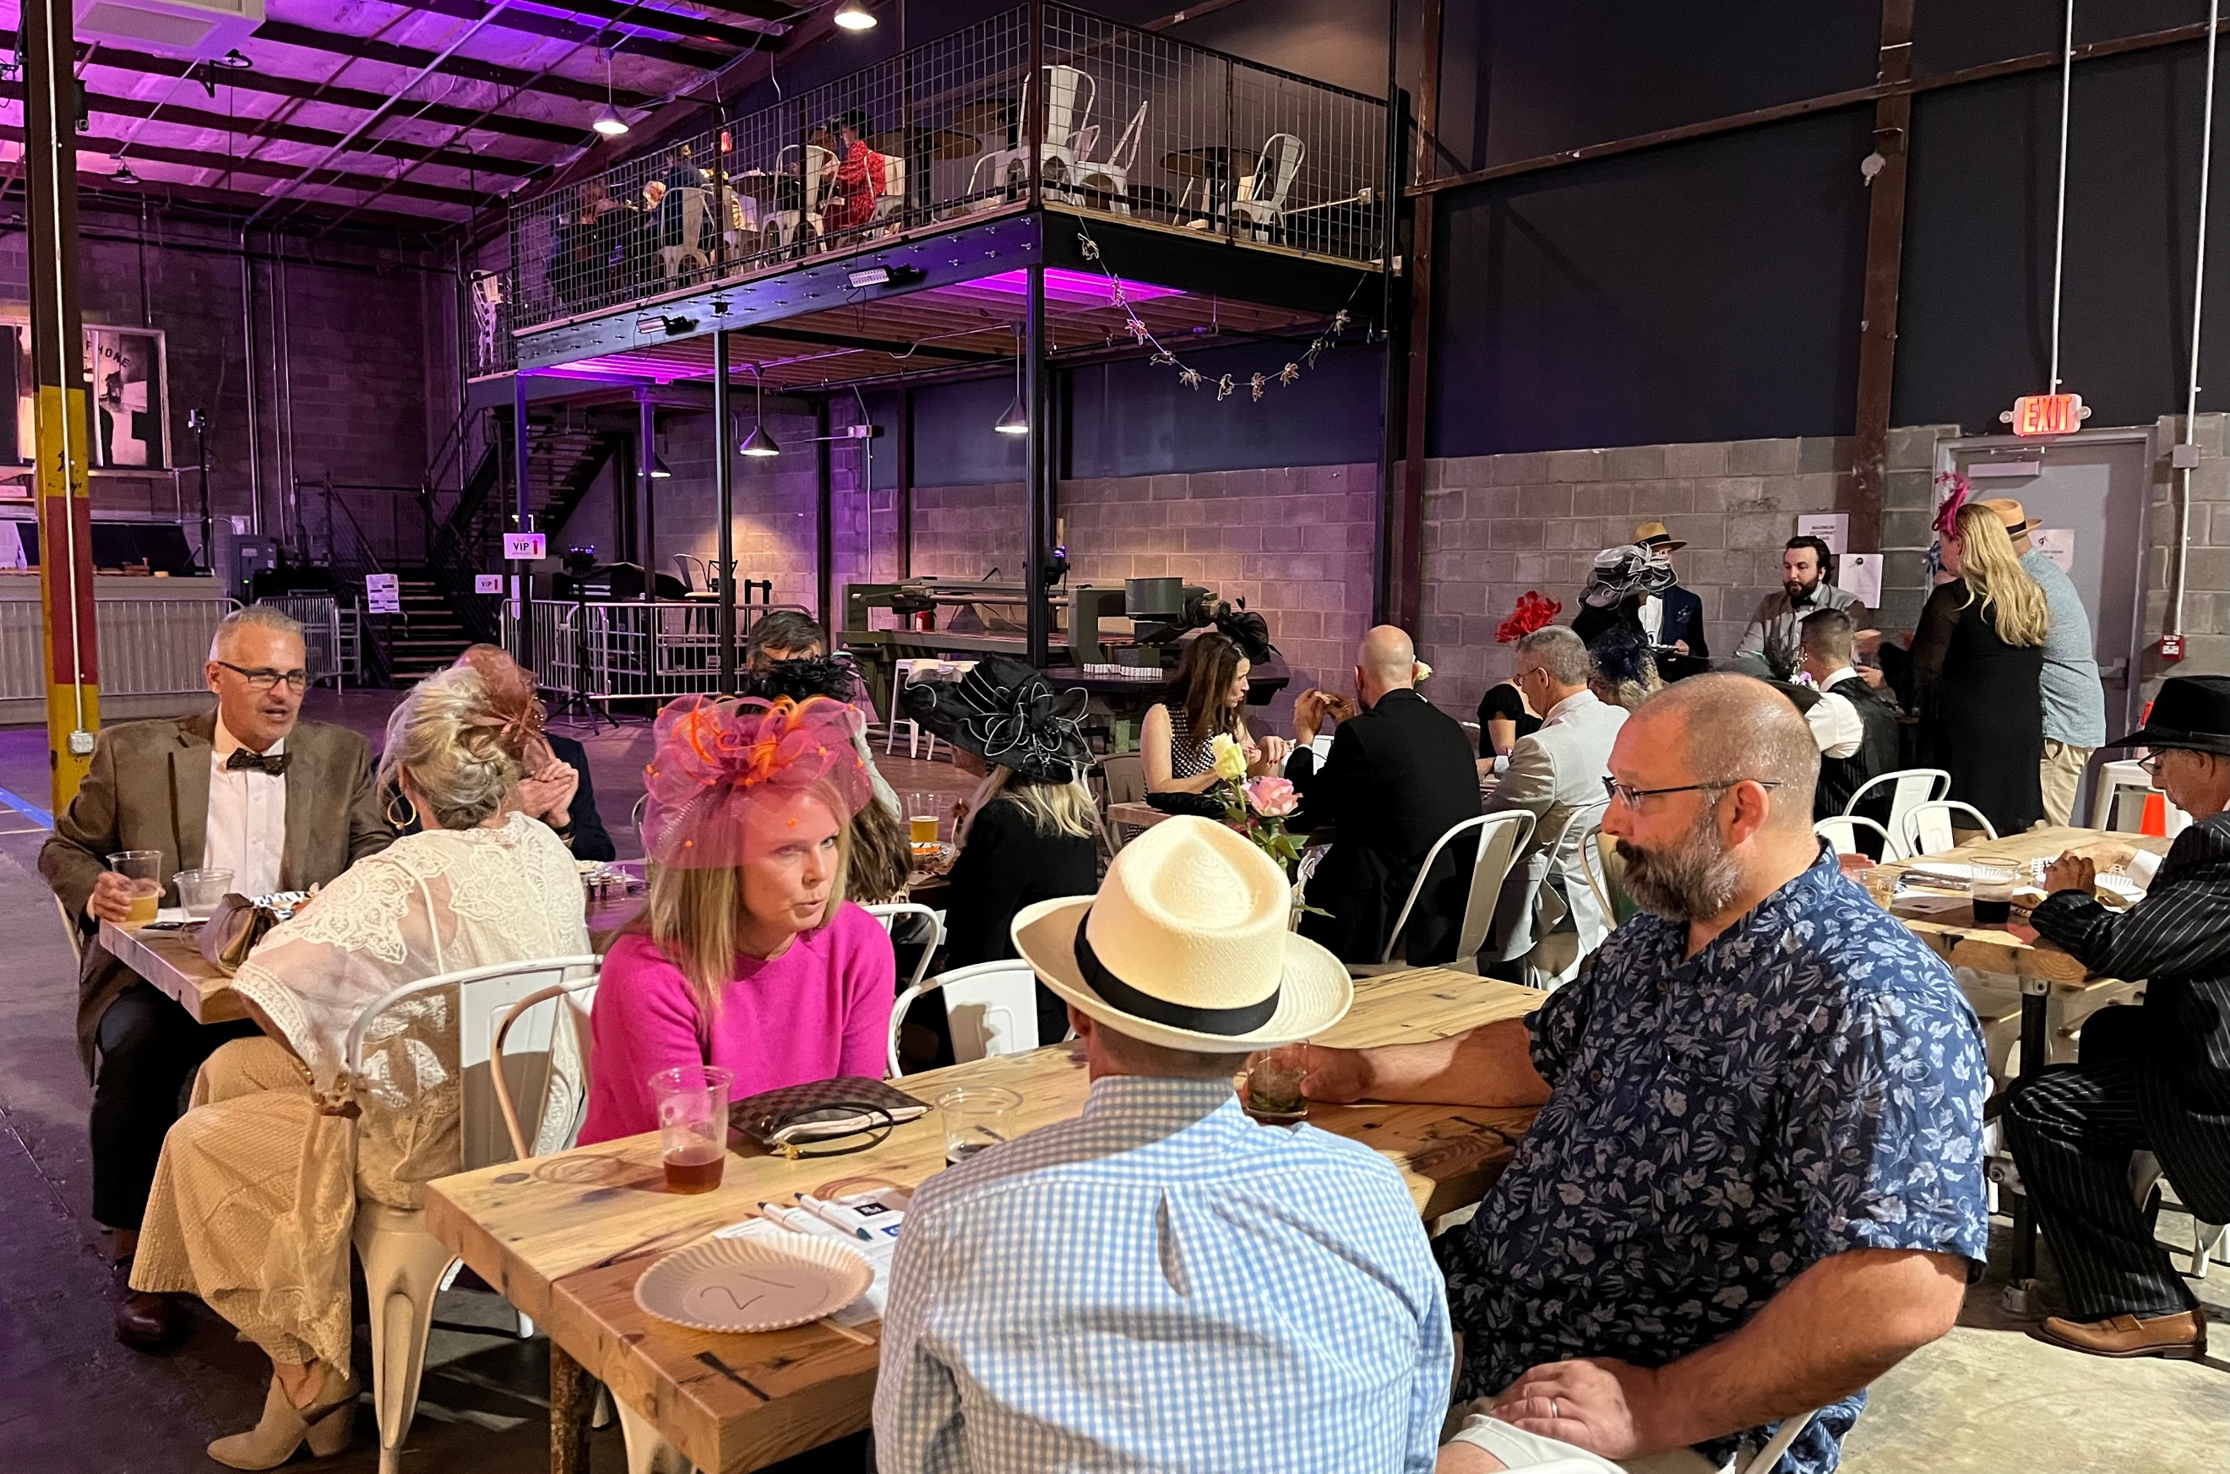  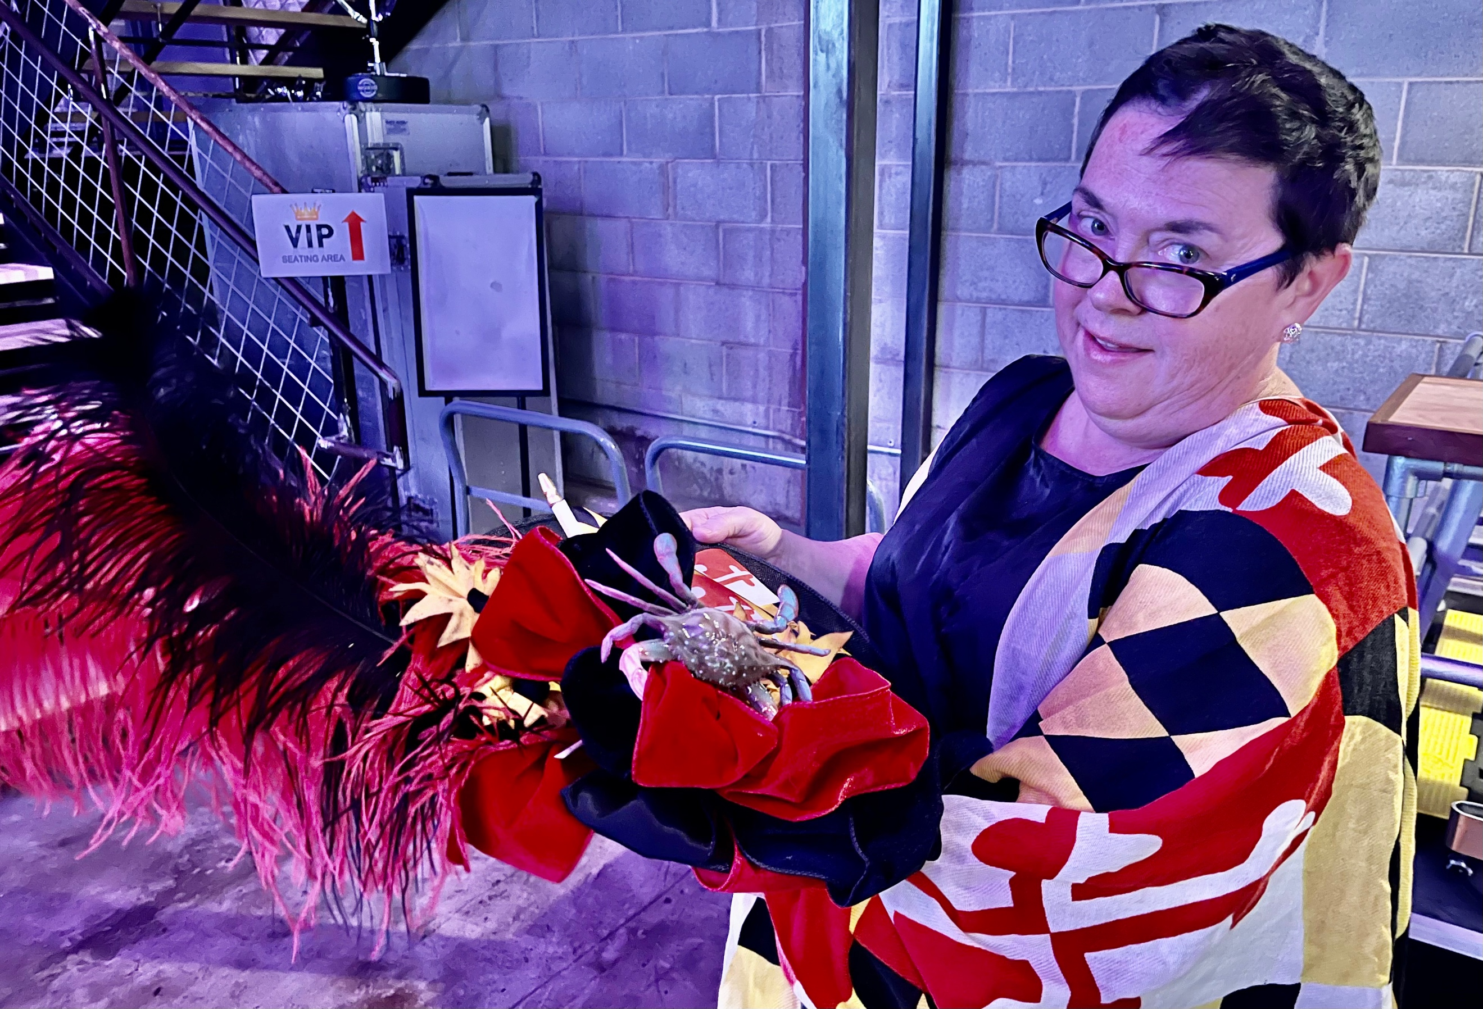 | Triple Crown Festival - Annual Fundraiser  Members and guests enjoyed an evening of racing, food, spirits and a live auction at the Foundry on Oct 27th. Vonda Lacey was the Triple Crown winner, Meg Huebeck had the best hat and Michelle White won gift cards for her betting skills. Live auction items included Rebecca Shin’s home cooked Korean dinner ($1000) and Paul Dana’s wooden train ($500). Thanks to emcee Jeff Fife, chair Hilary Quesenberry and her committee and all the sponsors! | 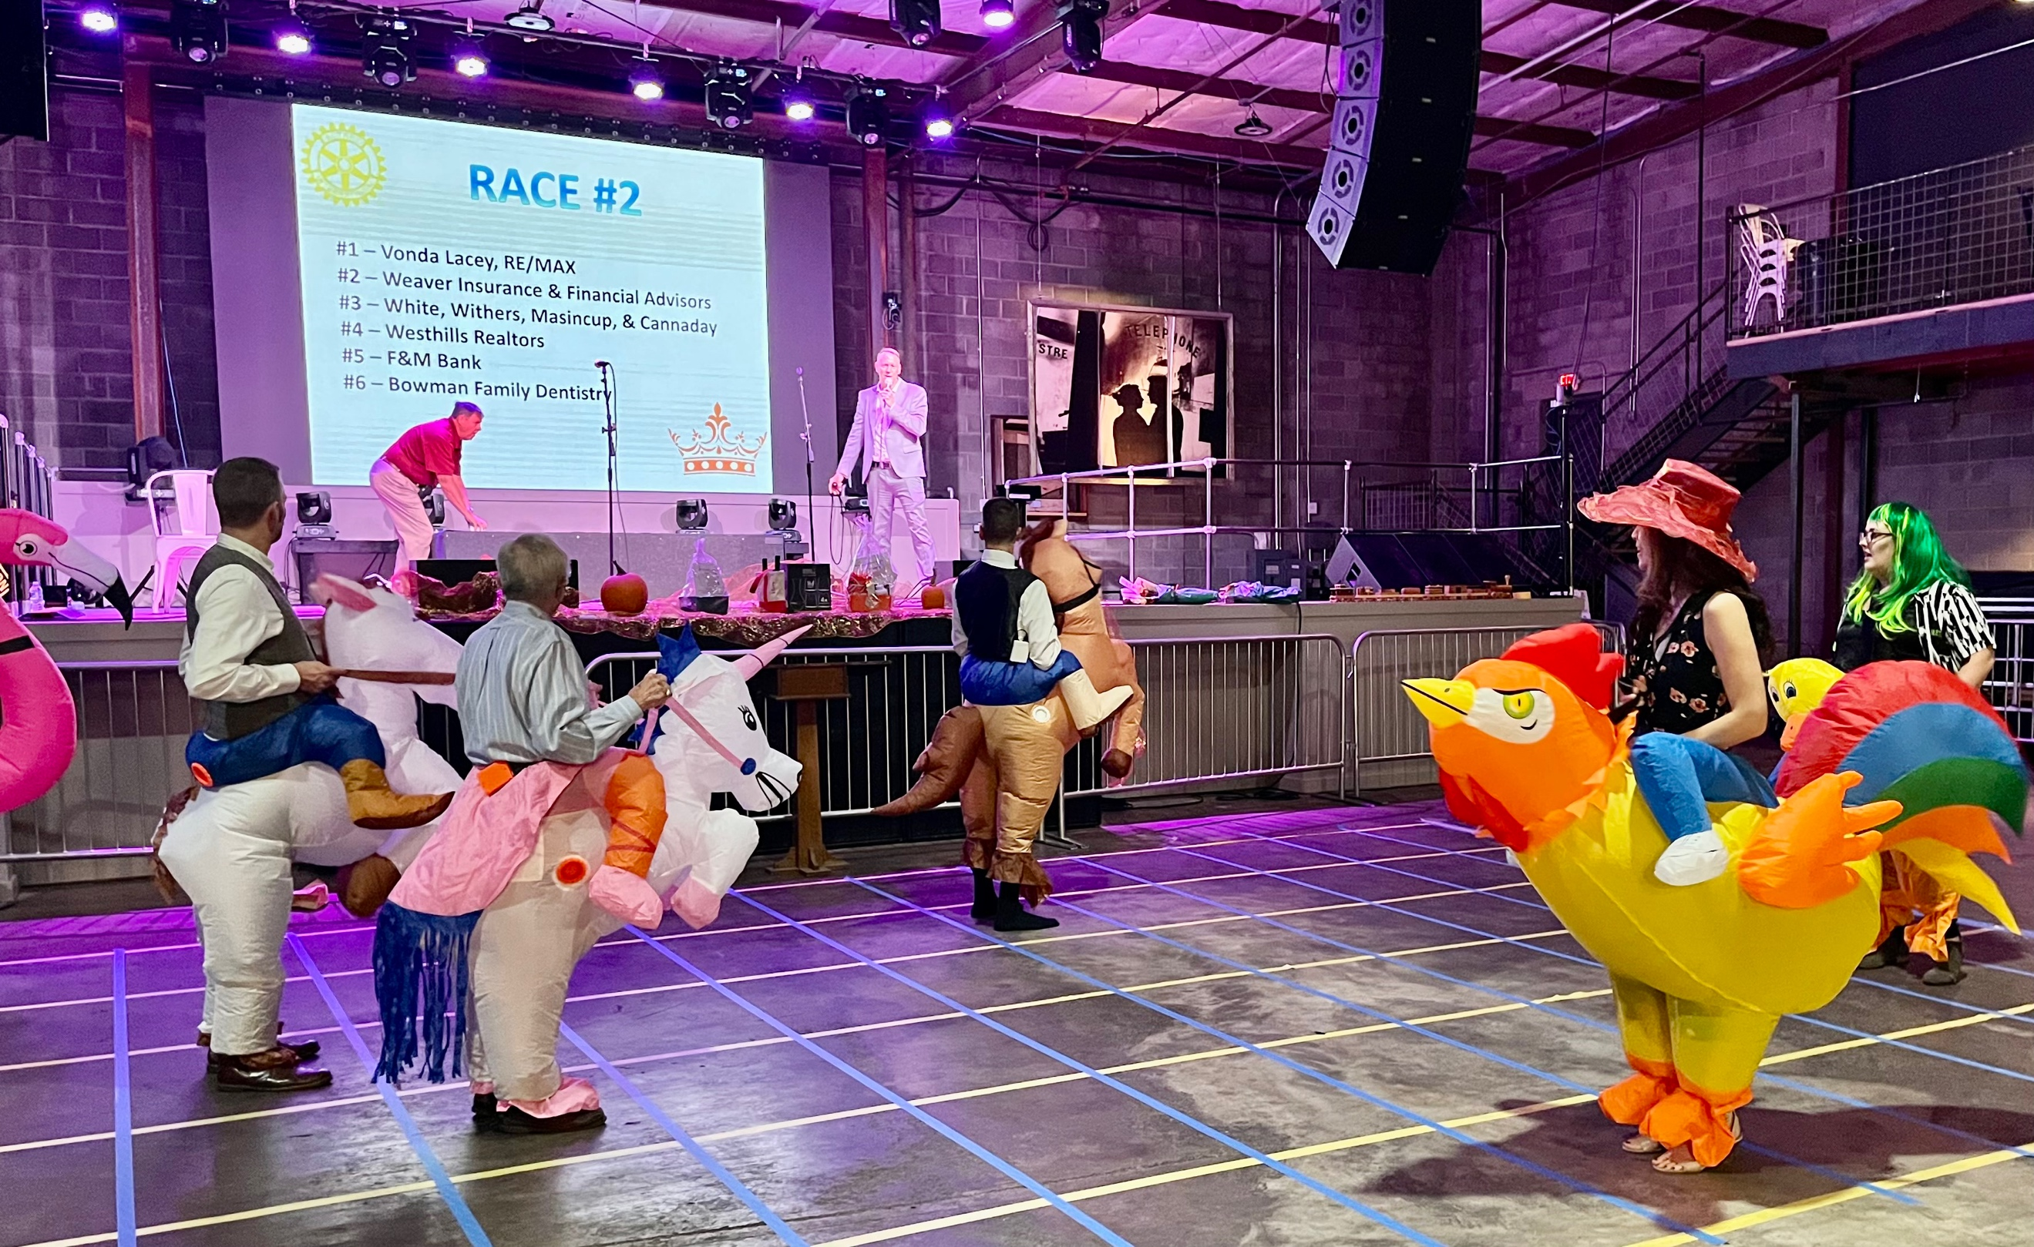  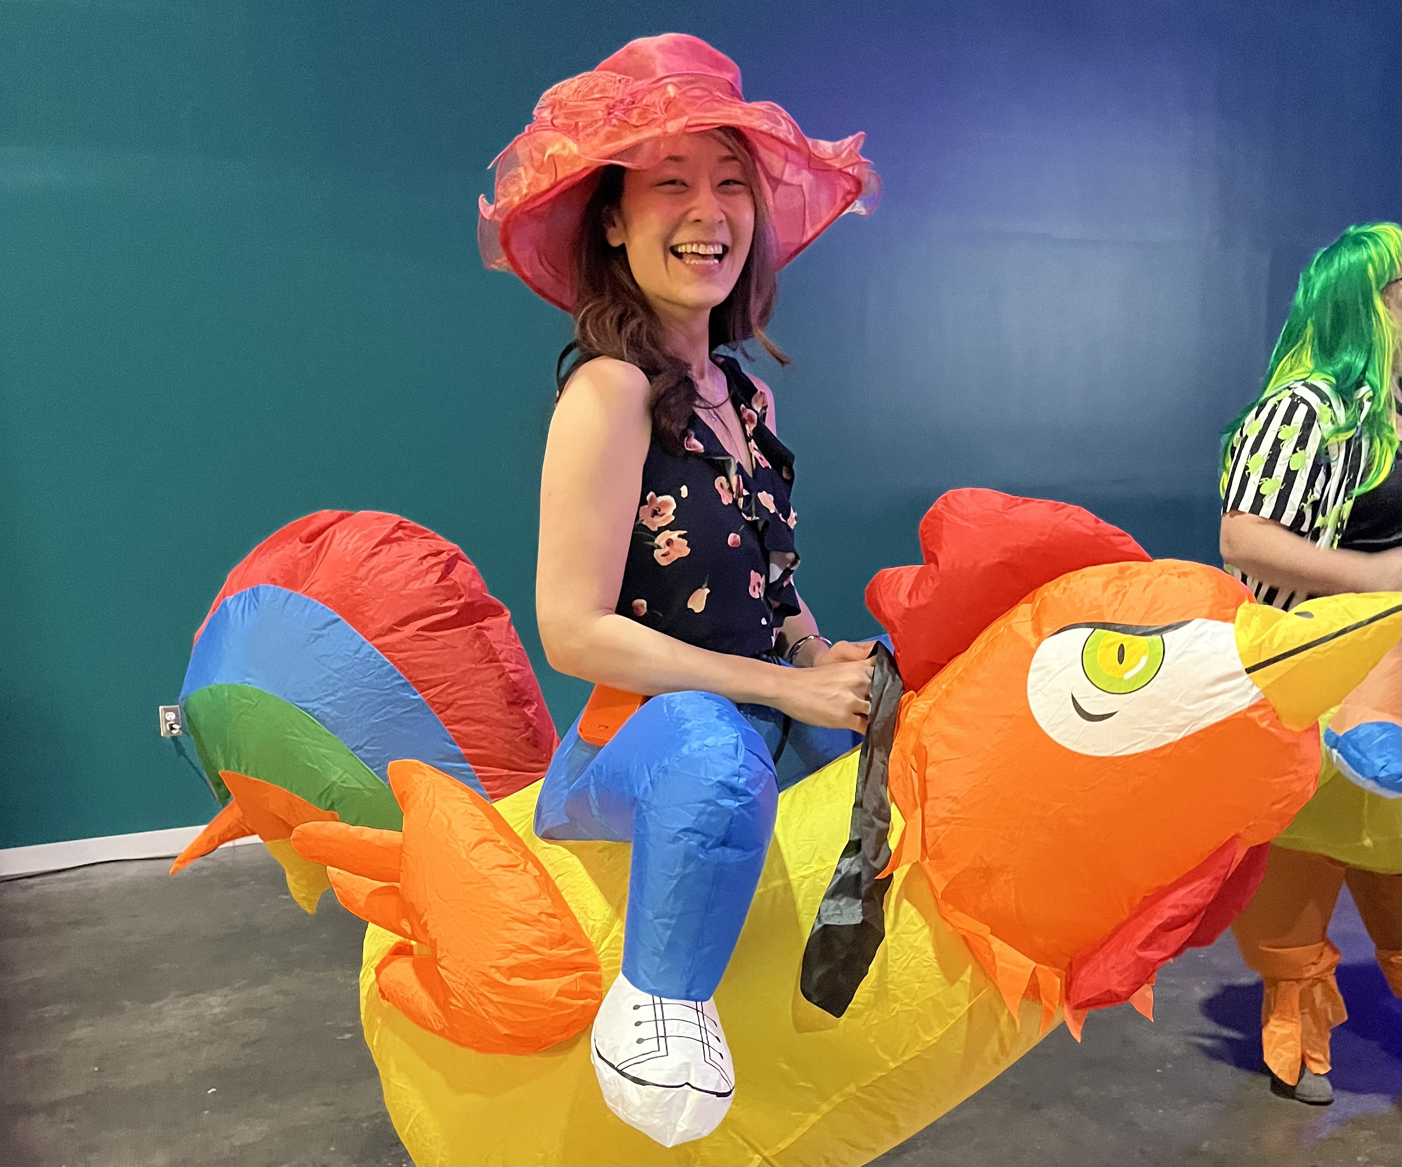
Proposed  Member | Nominee: Paula Figgatt Classification: Real Estate Asset Manager  Employer: University of Virginia Proposed by: Tim and Kirk Quillen  If there are no objections submitted, in writing, to the Board within ten days of this notice, this individual shall be duly qualified for membership in the Rotary Club of Waynesboro.

